**DS Lab**

**Exp-4**

**Name: Sushant Tulasi**

**Division: D20A**

**Roll no: 64**

**Aim:** To implement Fuzzy Membership Functions. Explain different member functions with plotting and Implement Singleton, triangular, Trapezoidal and gaussian membership functions.

**Theory:**

Membership functions are essential components in fuzzy logic systems, especially in the context of fuzzy sets and fuzzy inference systems. These functions define how each point in the input space is mapped to a membership value between 0 and 1. This membership value indicates the degree to which a given input belongs to a particular fuzzy set. There are several types of membership functions, each with unique characteristics suited for different applications. Below are four common types: Singleton, Triangular, Trapezoidal, and Gaussian.

### **1. Singleton Membership Function**

* **Definition:** A Singleton membership function assigns a membership value of 1 to a specific single point and 0 to all other points.
* **Shape:** The function is a vertical line at a single value on the x-axis where the membership is 1.
* **Mathematical Representation:**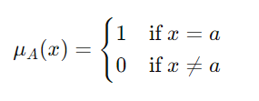  
  Where aaa is the point at which the membership value is 1.
* **Use Case:** Singleton membership functions are often used in discrete fuzzy sets or when the input is precise and only one specific value is considered fully belonging to the fuzzy set.

**Code:**

def singleton_mf(x, a):

return np.where(x == a, 1, 0)

# Singleton Plot

a = 2

plt.subplot(2, 2, 1)

plt.plot(x, singleton_mf(x, a), 'r', label=f'Singleton(a={a})')

plt.title('Singleton Membership Function')

plt.xlabel('x')

plt.ylabel('Membership')

plt.ylim(-0.1, 1.1)

plt.legend()

**Output:**  
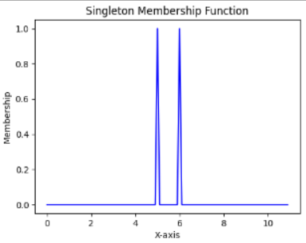

### **2. Triangular Membership Function**

* **Definition:** A Triangular membership function is defined by three parameters: a lower bound aaa, a peak bbb, and an upper bound ccc. The function linearly increases from aaa to bbb, then linearly decreases from bbb to ccc.
* **Shape:** The function forms a triangle, with the peak of the triangle at the point where the membership value is 1.
* **Mathematical Representation:  
  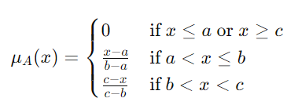**
* **Use Case:** Triangular membership functions are popular due to their simplicity and efficiency in computation. They are often used in fuzzy systems where the data can be approximated by linear segments.

**Code:**

# Triangular Membership Function

def triangular_mf(x, a, b, c):

return fuzz.trimf(x, [a, b, c])

# Triangular Plot

a, b, c = -5, 0, 5

plt.subplot(2, 2, 2)

plt.plot(x, triangular_mf(x, a, b, c), 'g', label=f'Triangular(a={a}, b={b}, c={c})')

plt.title('Triangular Membership Function')

plt.xlabel('x')

plt.ylabel('Membership')

plt.ylim(-0.1, 1.1)

plt.legend()

**Output:**

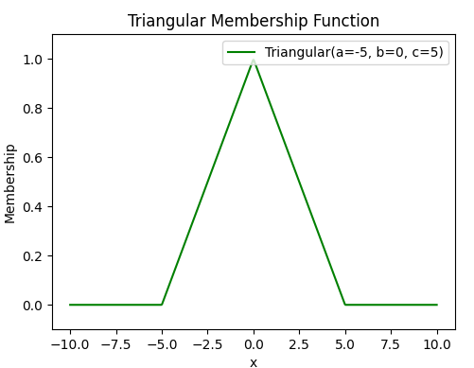

### **3. Trapezoidal Membership Function**

* **Definition:** A Trapezoidal membership function is an extension of the triangular function. It is defined by four parameters: aaa, bbb, ccc, and ddd. The function increases linearly from aaa to bbb, remains constant between bbb and ccc, and then decreases linearly from ccc to ddd.
* **Shape:** The function forms a trapezoid, with a flat top where the membership value is 1 between bbb and ccc.
* **Mathematical Representation:  
  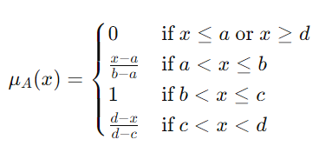**
* **Use Case:** Trapezoidal membership functions are useful when modeling ranges of values that have a certain level of certainty over a specific interval. They are frequently used in control systems and decision-making processes where such ranges occur.

**Code:**

# Trapezoidal Membership Function

def trapezoidal_mf(x, a, b, c, d):

return fuzz.trapmf(x, [a, b, c, d])

# Trapezoidal Plot

a, b, c, d = -7, -3, 3, 7

plt.subplot(2, 2, 3)

plt.plot(x, trapezoidal_mf(x, a, b, c, d), 'b', label=f'Trapezoidal(a={a}, b={b}, c={c}, d={d})')

plt.title('Trapezoidal Membership Function')

plt.xlabel('x')

plt.ylabel('Membership')

plt.ylim(-0.1, 1.1)

plt.legend()

**Output:**

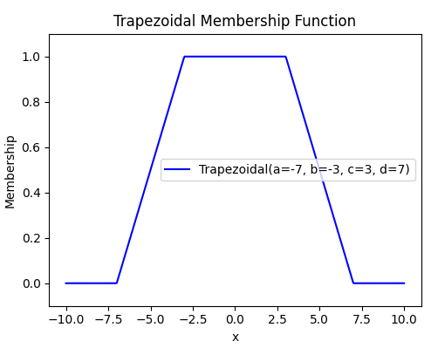

### **4. Gaussian Membership Function**

* **Definition:** A Gaussian membership function is defined by a bell-shaped curve, characterized by its mean ccc and standard deviation σ\sigmaσ. It is smooth and has no abrupt changes.
* **Shape:** The function forms a symmetrical bell curve centered around the mean ccc.
* **Mathematical Representation:  
  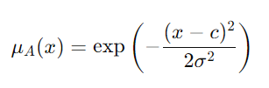**  
  Where:
  + ccc is the mean (center of the curve).
  + σ\sigmaσ is the standard deviation (controls the width of the bell curve).
* **Use Case:** Gaussian membership functions are widely used in situations requiring smooth transitions and are ideal for systems where noise and uncertainty need to be handled gracefully. They are often used in systems with a need for non-linear mappings.

**Code:**

# Gaussian Membership Function

def gaussian_mf(x, mean, sigma):

return fuzz.gaussmf(x, mean, sigma)

# Gaussian Plot

mean, sigma = 0, 2

plt.subplot(2, 2, 4)

plt.plot(x, gaussian_mf(x, mean, sigma), 'm', label=f'Gaussian(mean={mean}, sigma={sigma})')

plt.title('Gaussian Membership Function')

plt.xlabel('x')

plt.ylabel('Membership')

plt.ylim(-0.1, 1.1)

plt.legend()

**Output:**

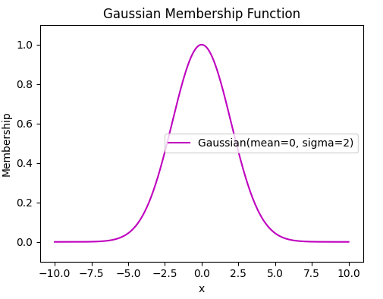

**Conclusion:**

Each of these membership functions has its strengths and is chosen based on the specific needs of the fuzzy logic system. Singleton functions are simple and precise, triangular and trapezoidal functions are computationally efficient and easy to implement, and Gaussian functions are preferred for smooth transitions and handling uncertainties.